**Menu Bar**

| Home  (index.html) | About | Tutorial  (tutorial.html) | Cases  (cases.html) | Controversy (controversy.html) | Receptions  (reception.html) | Resources  (resources.html) | Contact  (contact-us.html) |
| --- | --- | --- | --- | --- | --- | --- | --- |
|  | What is Suno (about.html) |  |  |  |  |  |  |
|  | Other-GenAI  (other-GenAI.html) |  |  |  |  |  |  |

**Page Content**

**Home**

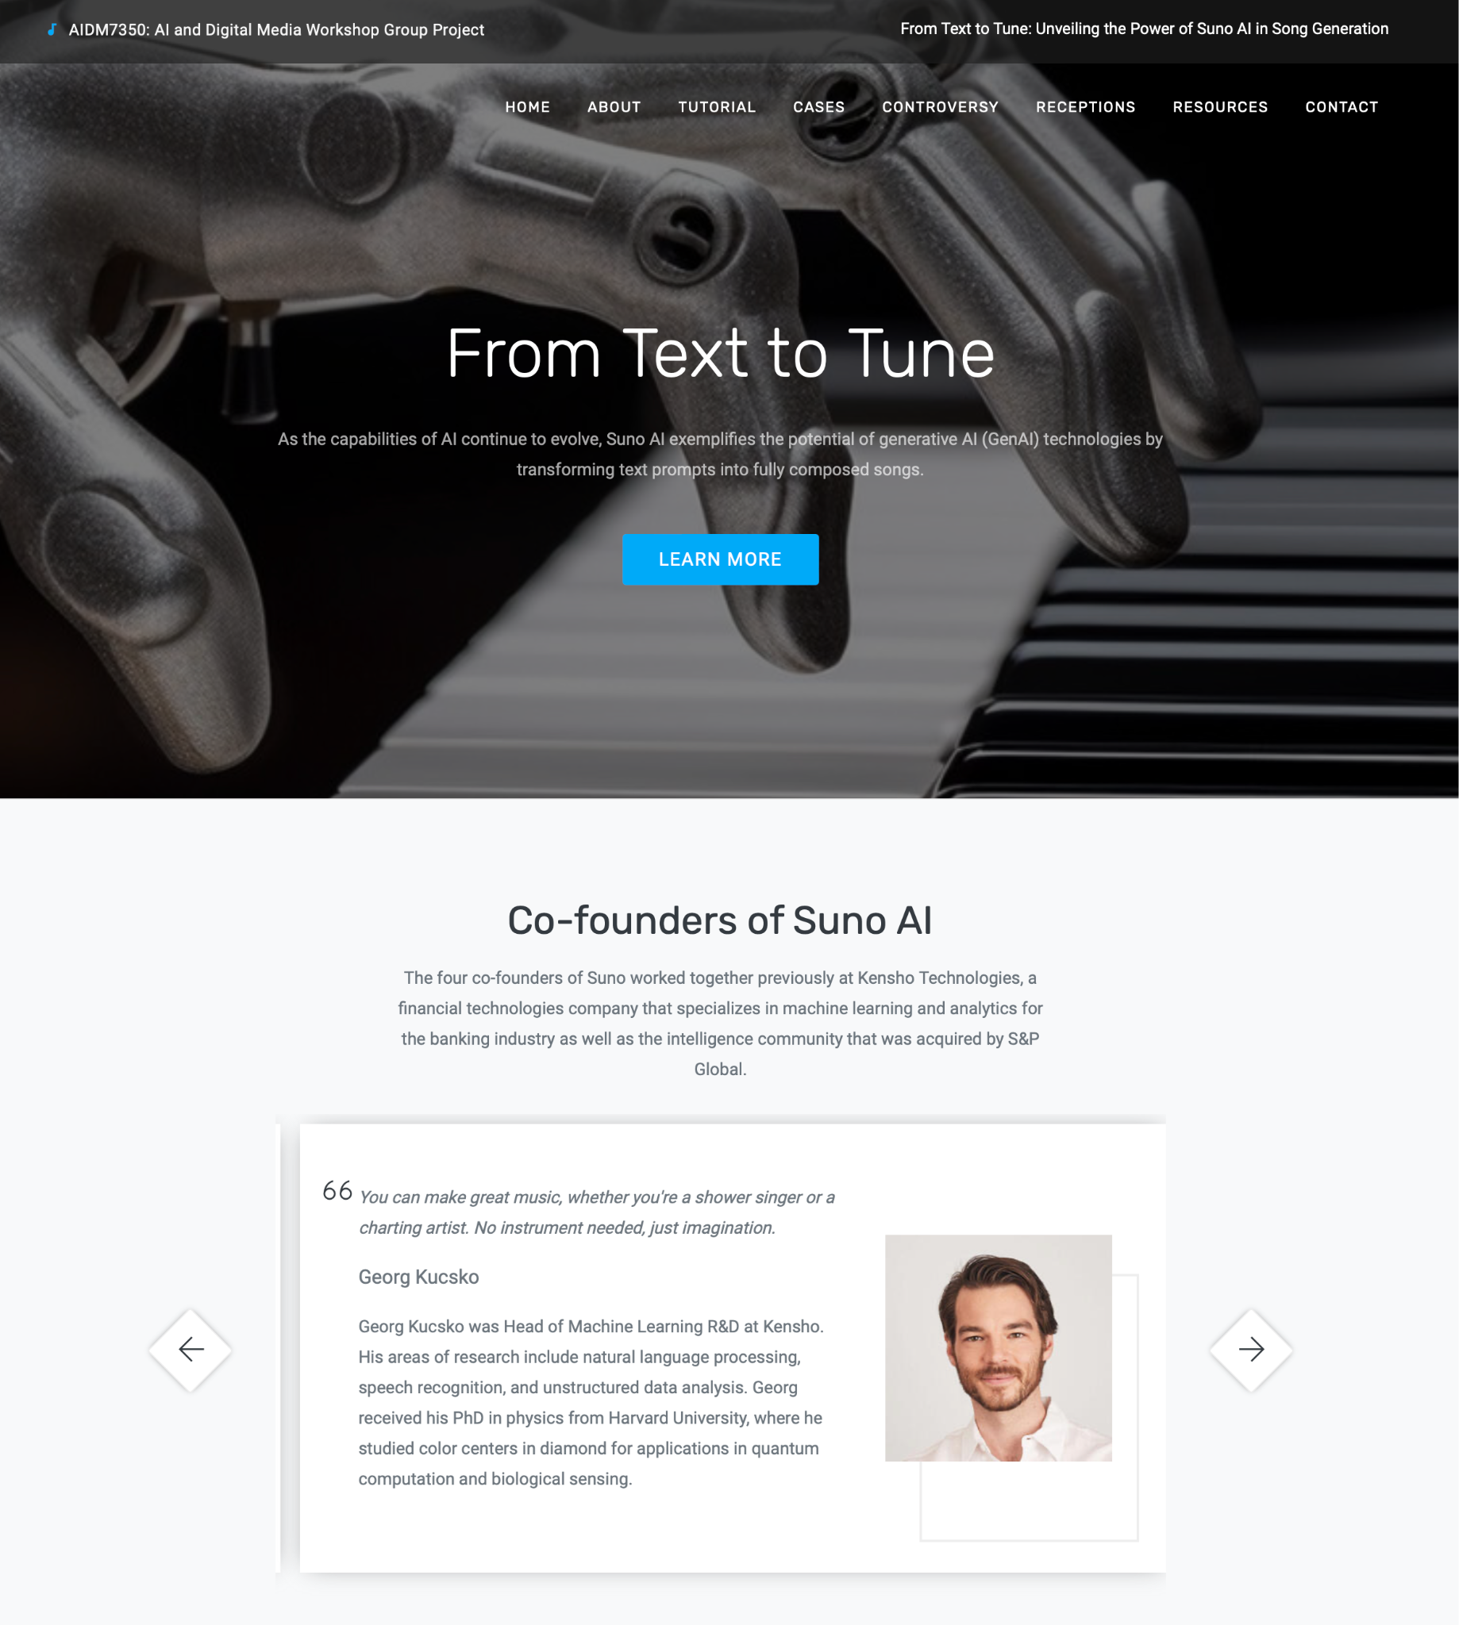

**About**

**What is Suno**

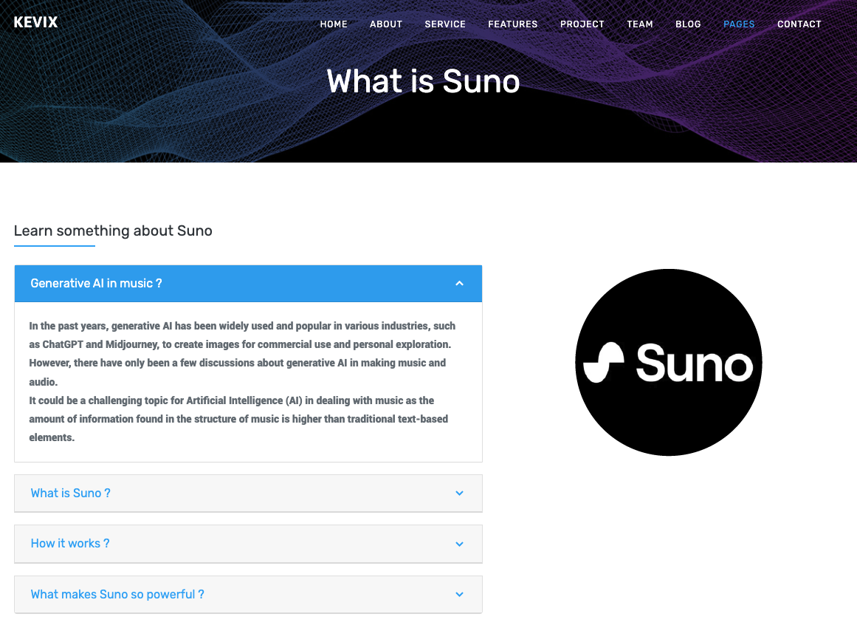

**Other GenAI music platforms**

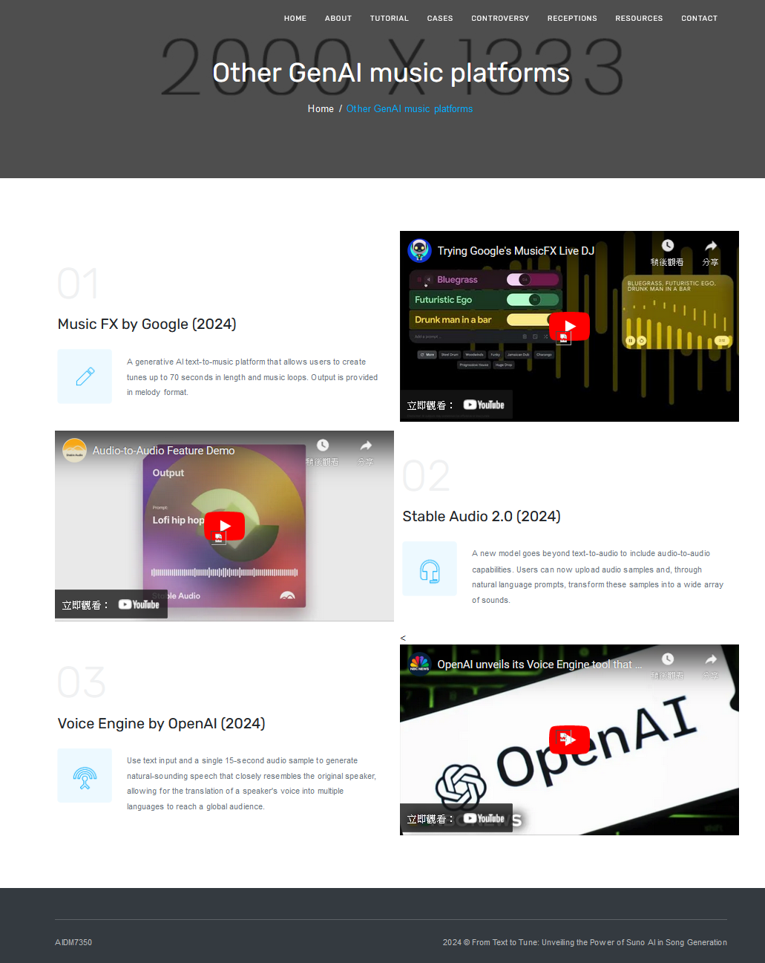

**Tutorial**

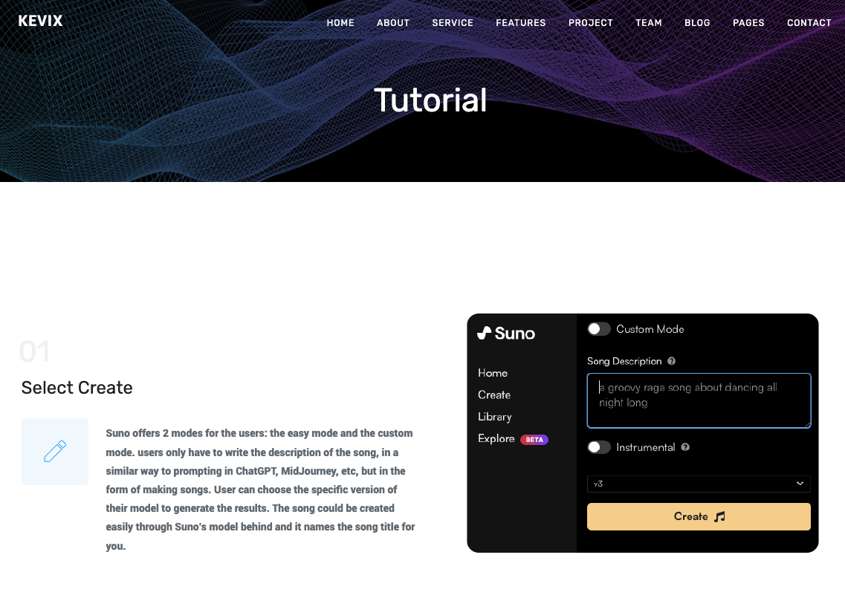

**Cases**

**Landing**

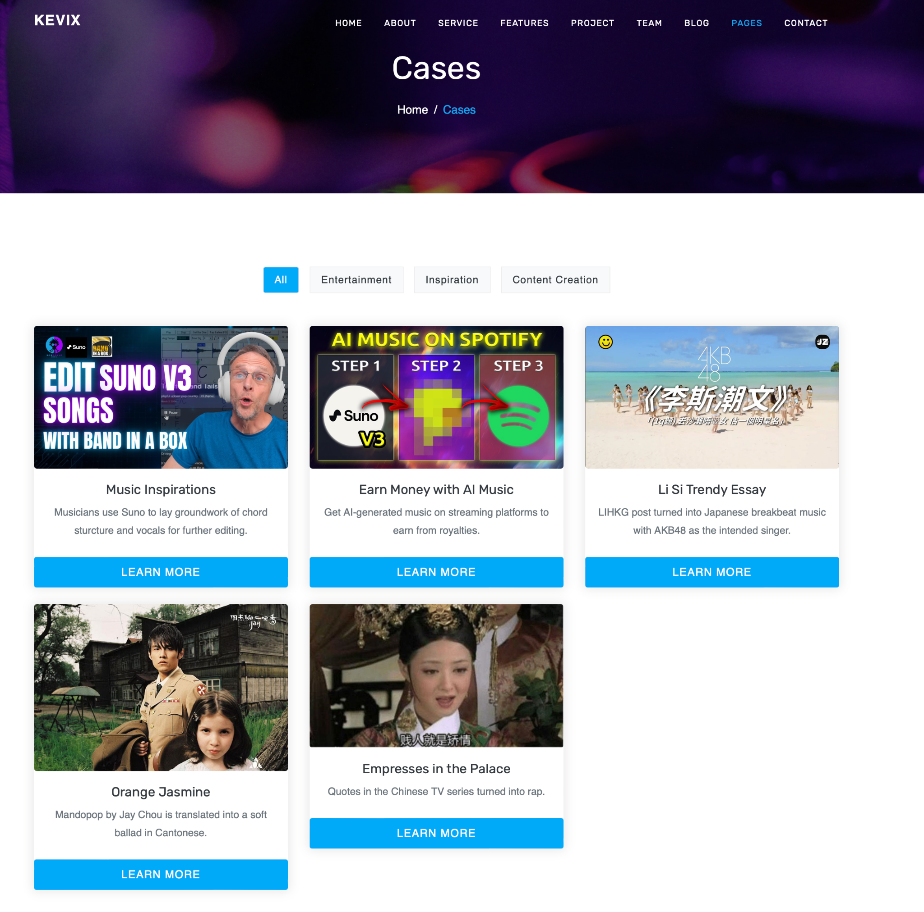

**Subpage**

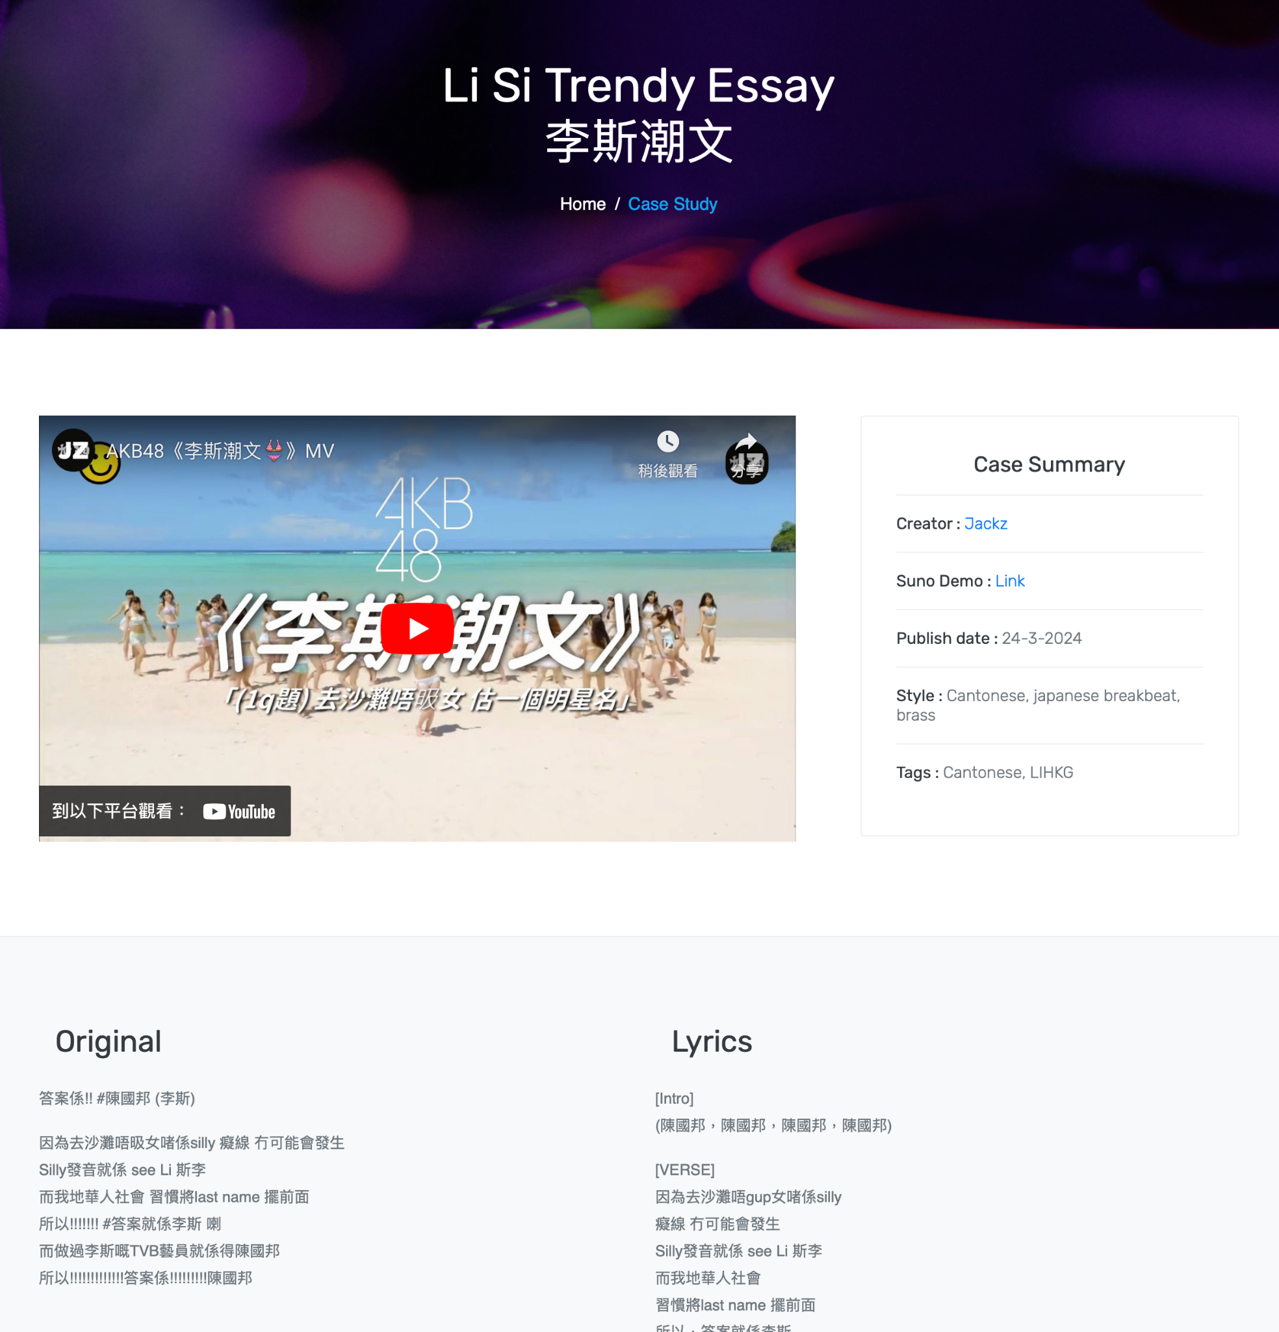

**Controversy**

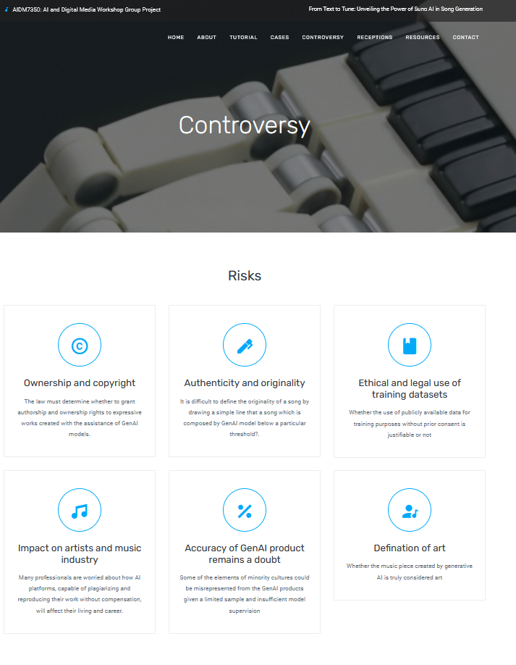

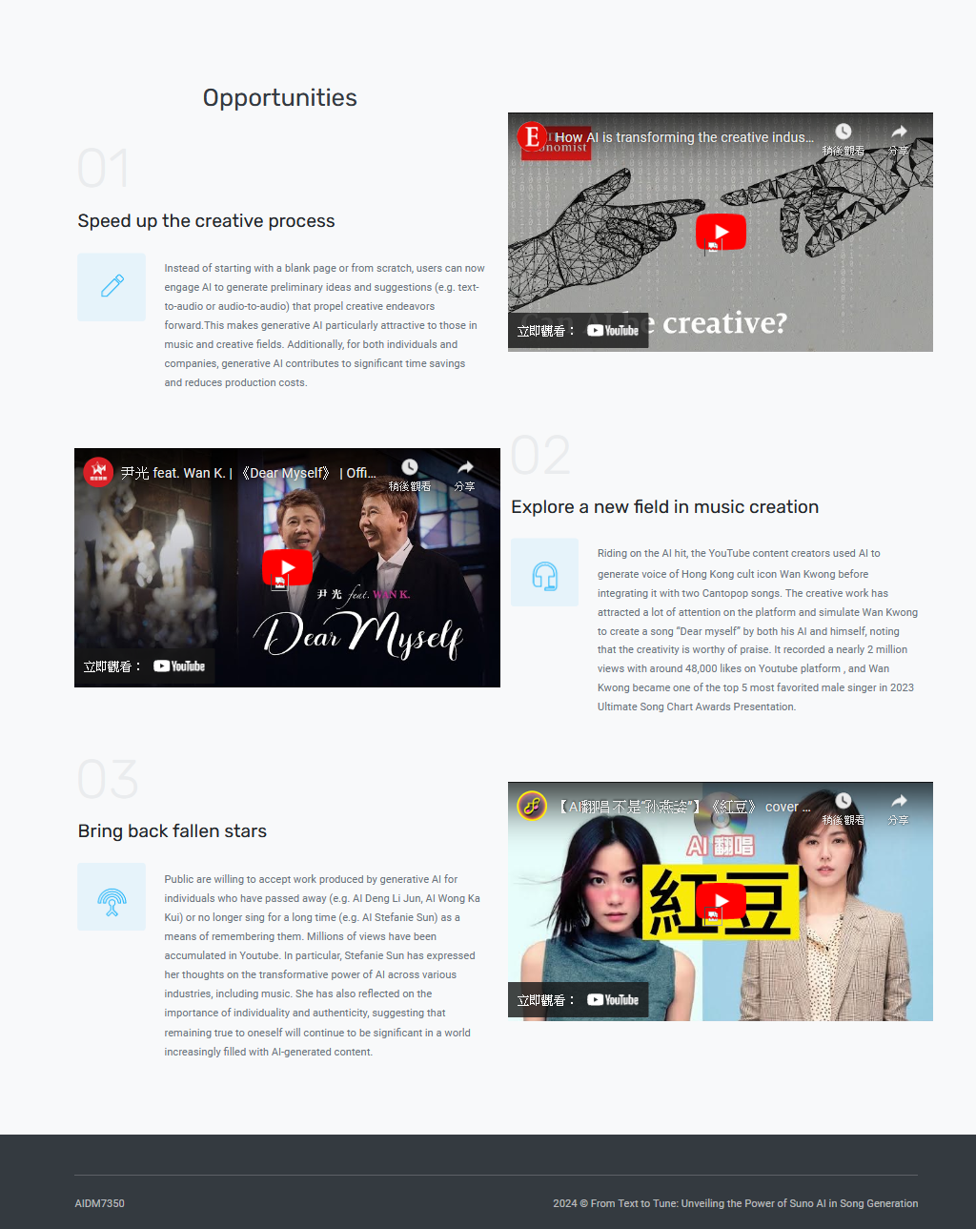

**Receptions**

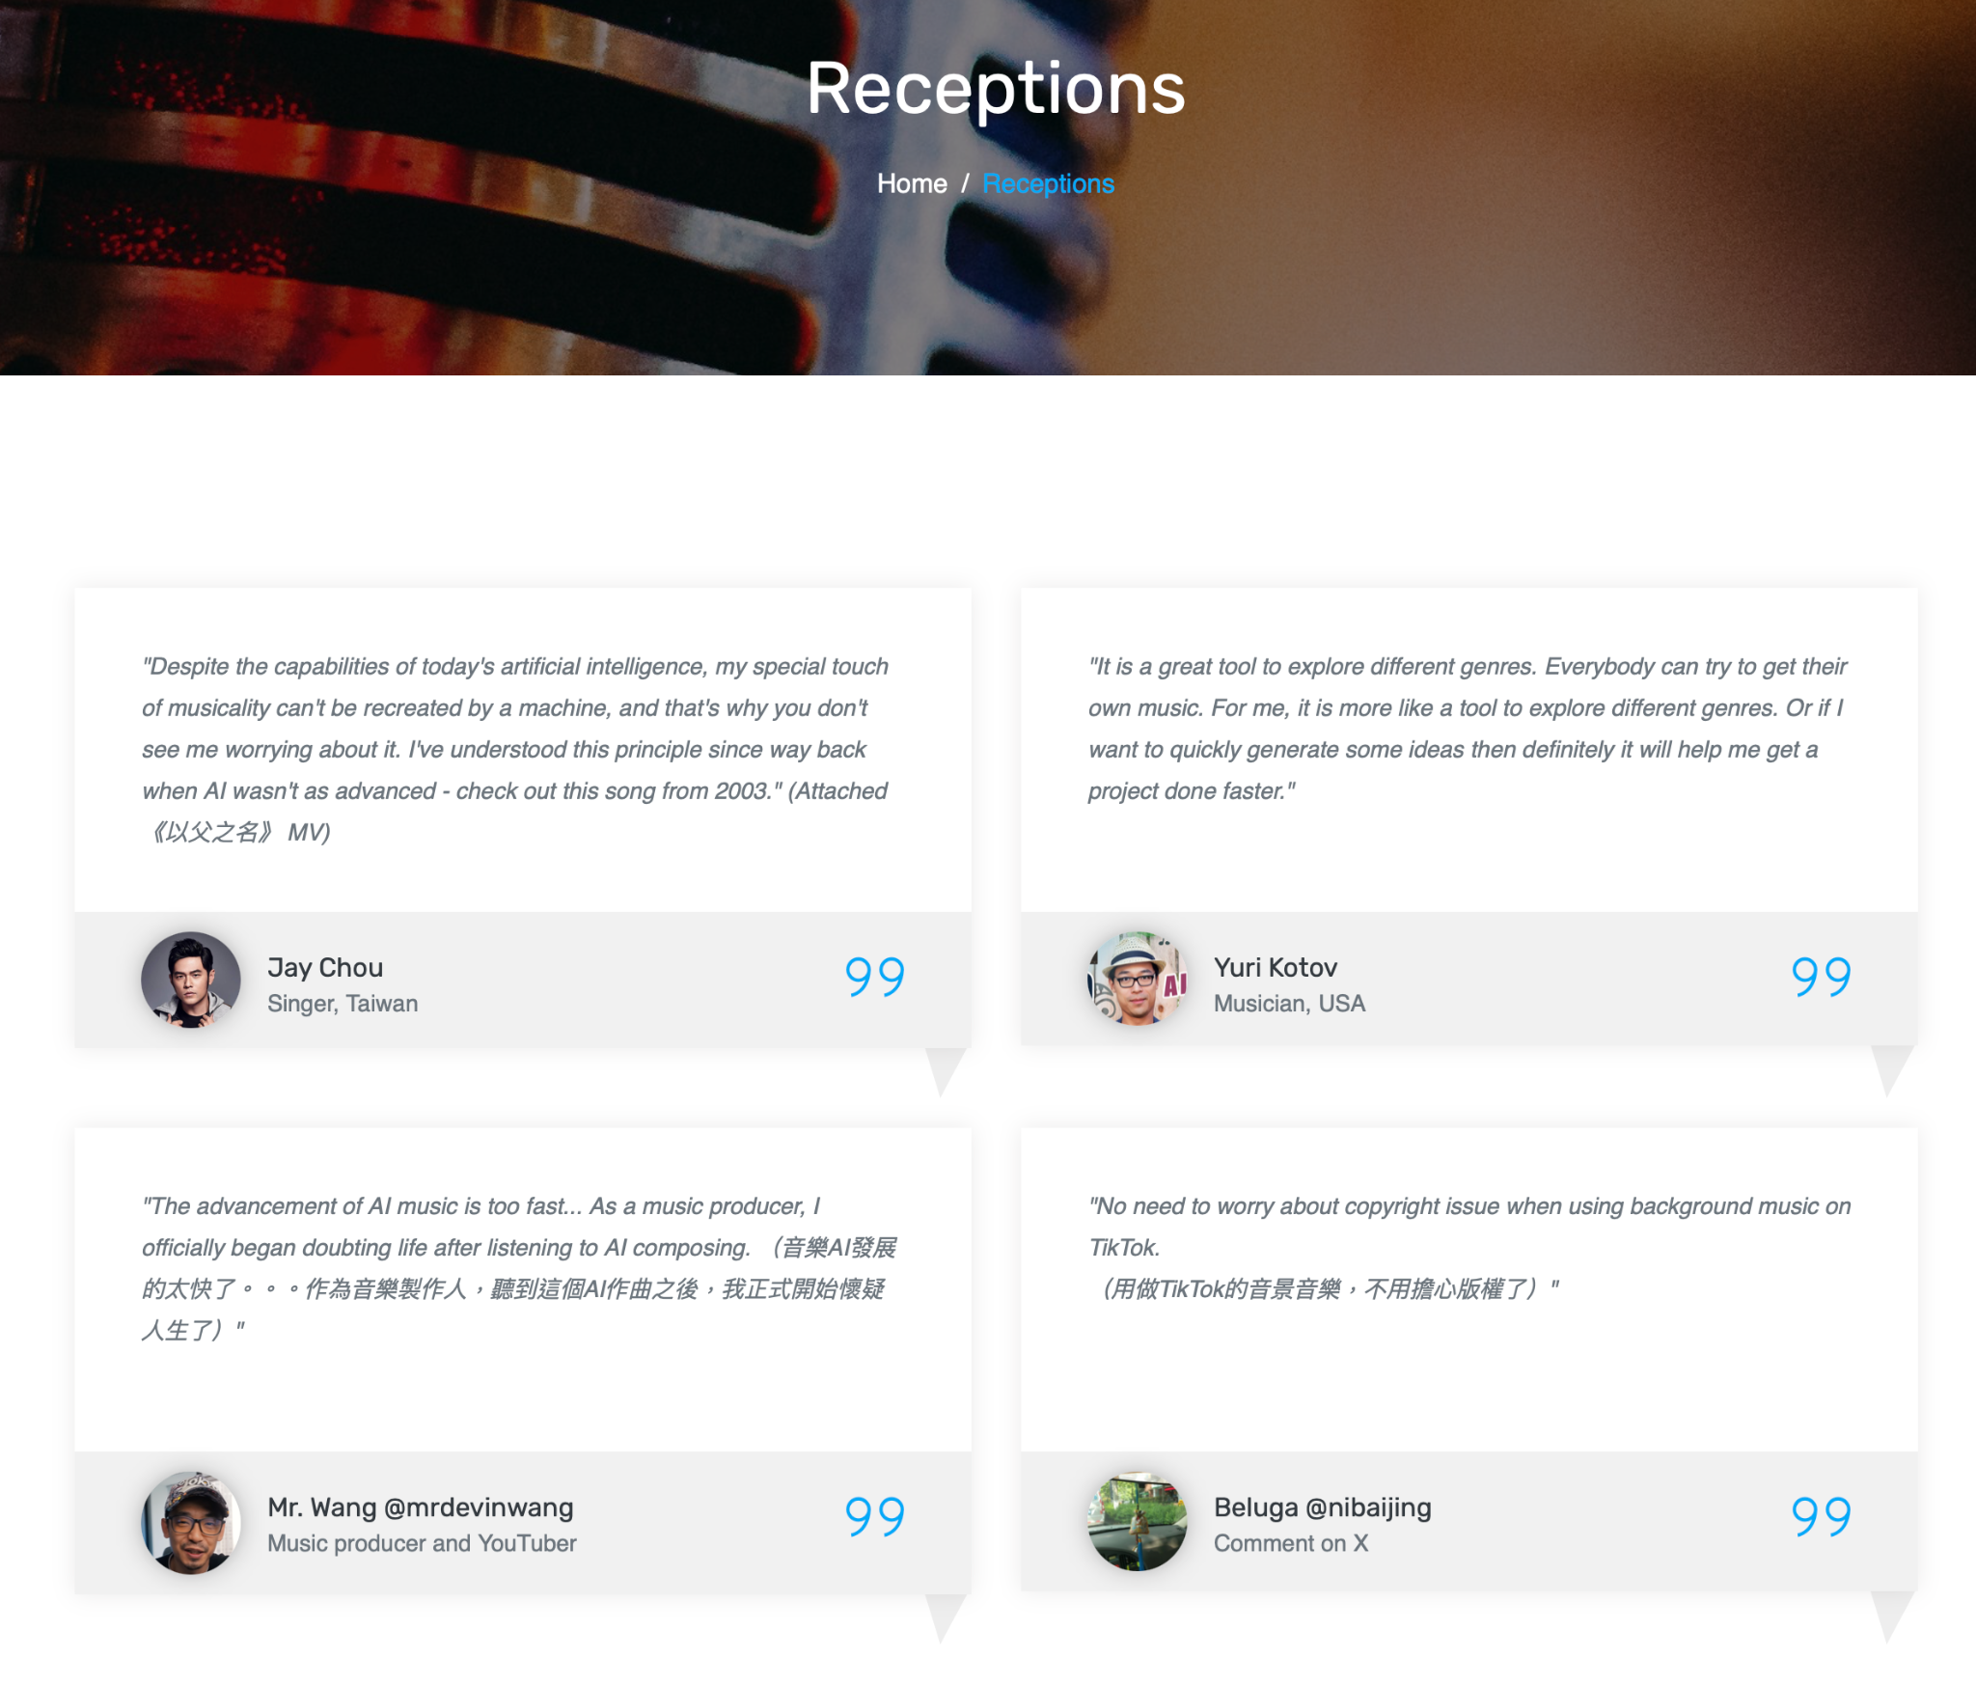

Resources

Contact

**1. Home**

- Introduction to the website and its purpose.

- Highlights of the capabilities of GenAI in songwriting, using Suno as a case study.

- Featured examples of songs generated by Suno.

**2. About GenAI in Songwriting**(Yiu)

- Overview of the use of artificial intelligence in music composition and songwriting.

- Explanation of how GenAI technologies like Suno work to generate songs from text prompts.

In the past years, generative AI has been widely used and popular in various industries, such as ChatGPT and Midjourney, to create images for commercial use and personal exploration. However, there have only been a few discussions about generative AI in making music and audio.

It could be a challenging topic for Artificial Intelligence (AI) in dealing with music as the amount of information found in the structure of music is higher than traditional text-based elements.

https://www.rollingstone.com/music/music-features/suno-ai-chatgpt-for-music-1234982307/

Suno AI is a newly generative AI platform for music, with the power to enable users to create with imagination with text by prompting based on its own trained model behind, just like the “ChatGPT for Music.”

https://www.zdnet.com/article/what-is-suno-this-chatgpt-for-music-generates-songs-in-seconds/

Although Suno does not reveal the principle of their processing behind, machine learning and deep learning are commonly used in the AI generation of music production. For instance, Recurrent Neural Networks (RNN) can be used for the interpretation of input sequences to generate the outcomes while the Long Short Term Memory (LSTM) networks can capture the thematic development of the music piece.

With the additional help of Convolutional Neural Networks (CNNs), feature extraction can be executed in the music training datasets. The model is trained with numerous datasets to learn the patterns of the musical structures, including the compositions, genres, and styles in different types of music.

CEO and Co-Founder, Mikey Shulman, said: "Not all audio is done with transformers, there's a lot of audio that's done with diffusion – and these two methods have pros and cons”

**3. How Suno Works**(Yiu)

- Detailed explanation of Suno's functionality and technology stack.

- Step-by-step guide on how users can input text prompts and generate songs using Suno.

- Showcase of different genres and themes that Suno can generate songs for.

**What makes Suno so powerful?**

The Semantic Recognition power

In contrast to previous generative AI platforms primarily relying on pattern recognition and statistical modeling, Suno integrates natural language processing (NLP) methods to understand textual prompts. This empowers Suno to compose music that maintains structural coherence and resonates thematically with the user's input.

Extensive Customization

Suno provides high customization and interactivity, allowing users to input specific text prompts and adjust various parameters to tailor the generated music to their preferences. Users can define genre preferences, mood, instrumentation, and other musical aspects, resulting in a deeply personalized and immersive journey.

Seamless Integration of Text and Music:

Suno seamlessly integrates text and music generation processes, ensuring the generated compositions reflect the intended themes and emotions conveyed in the input text. By dynamically adjusting musical parameters based on the semantic content of the text, Suno produces compositions that feel cohesive and expressive.

Scalability and Performance

It handles enormous volumes of data and computational tasks with efficiency. Suno maintains a high-performance level to deliver fast and convincing results and ensure the growing demand for users in the music production industry.

**How to use Suno?**

Making a song with Suno is simple. Regarding the creation, Suno offers two modes for the users: the easy mode and the custom mode.

In the easy mode, users only have to write the description of the song, in a similar way to prompting in ChatGPT, MidJourney, etc, but in the form of making songs. User can choose the specific version of their model to generate the results. The song could be created easily through Suno’s model behind and it names the song title for you.

On the other hand, the Custom Mode offers more adjustable parameters for the creator with more ideas. It enables the users to enter their lyrics in the song. By choosing the style by inputting keywords, users can set the vibe, mood, and voice according to their keywords to generate their tailor-made genre. Then, after naming the title and the mentioned details, Suno integrated all the parameters to create the song in a few minutes.

For both modes, there is an option “Instrumental” for choosing whether the output is only composed with lyrics and vocals or only music.

After your creation, you can view your own pieces in the Library on the Suno platform, or you could explore other users' works in the community in Suno.

**4. Exploring Suno's Output** (Nelly)

- Sample songs generated by Suno across various genres and themes.

- Analysis of Suno's output in terms of composition, lyrics, instrumentation, and overall coherence.

- User testimonials and feedback on their experiences with Suno-generated songs.

- 連登潮文

**5. GenAI in Music Industry**(Sally)

- Case studies of other GenAI platforms and tools used in the music industry.

- Interviews with musicians, producers, and industry experts on the role of AI in songwriting and music production. - Youtuber reaction

- Discussion on the potential benefits and challenges of integrating GenAI into the music-making process. - Discussion on the impact of GenAI on the music industry and creative processes.

尹光 (positive to GenAI in music industry):

Potential competitors/ alternatives/ Platforms that innovate/revoluate the GenAI in the music industry/ landscape

[**MusicFX (Google)**](https://aitestkitchen.withgoogle.com/tools/music-fx)**: a model generating high-fidelity music from text descriptions such as "a calming violin melody backed by a distorted guitar riff". MusicLM casts the process of conditional music generation as a hierarchical sequence-to-sequence modeling task, and it generates music at 24 kHz that remains consistent over several minute**

MusicFX still has a limited rollout: it’s available in the US, New Zealand, Kenya and Australia. So, 10m tracks created in those four countries alone so far.

<https://musically.com/2024/02/06/googles-musicfx-ai-tool-has-been-used-to-create-10m-tracks/>

No vocal

[**MusicGen (Meta AI)**](https://github.com/facebookresearch/audiocraft): single Language Model (LM) that operates over several streams of compressed discrete music representation, i.e., tokens. Unlike prior work, MusicGen is comprised of a single-stage transformer LM together with efficient token interleaving patterns, which eliminates the need for cascading several models, e.g., hierarchically or upsampling. Following this approach, we demonstrate how MusicGen can generate high-quality samples, both mono and stereo, while being conditioned on textual description or melodic features, allowing better controls over the generated output. We conduct extensive empirical evaluation, considering both automatic and human studies, showing the proposed approach is superior to the evaluated baselines on a standard text-to-music

[OpenAI's MuseNet](https://openai.com/research/musenet): It can generate 4-minute musical compositions using 10 different instruments. It leverages cutting-edge machine-learning models. It's an excellent tool for musicians experimenting with different genres. This is due to its ability to blend various styles. Best for: Musicians looking for a versatile tool to explore different styles and instrument combinations.

[**Stable Audio (Stability AI)**](https://stability.ai/stableaudio)**: The new model goes beyond text-to-audio to include audio-to-audio capabilities. Users can now upload audio samples and, through natural language prompts, transform these samples into a wide array of sounds. This update also expands sound effect generation and style transfer, providing artists and musicians more flexibility, control, and an elevated creative process.**

MIDI-DDSP: a widely used digital music standard for creating music in live performances or recordings. It allows us to use notes and control signals to play synthesizers and samplers, for instance, sending “note-on” and “note-off” information when pressing a key of a MIDI piano keyboard. While synthesizers can produce many sounds for each note, it is difficult to find control settings to produce realistic-sounding audio. On the other hand, samplers and black-box neural audio synthesis (e.g., [WaveNet](https://magenta.tensorflow.org/maestro-wave2midi2wave)) can sound more realistic but offer less individual control.

[Jukebox (OpenAI)](https://openai.com/blog/jukebox/): a model that generates music with singing in the raw audio domain. We tackle the long context of raw audio using a multi-scale VQ-VAE to compress it to discrete codes, and modeling those using autoregressive Transformers. We show that the combined model at scale can generate high-fidelity and diverse songs with coherence up to multiple minutes. We can condition on artist and genre to steer the musical and vocal style, and on unaligned lyrics to make the singing more controllable.

<https://www.nichepursuits.com/best-ai-music-generator/>

OpenaAI Voice Engineer

Benefits: Enhanced creativity/ cost-effective/ efficiency and productivity/ accessibility/ persobalization/ experimental music

Challenges: Artistic authenticity/ intellectual property issues/ economic impacts/ dependence on technology/ quality concerns/ lack of variety/ industry fragmentation/ spirit (emotion connectivity)

Quotes: Ppl’s comments on GenAI in music industry

尹光

<https://www.youtube.com/watch?v=hDSft4Ah1Qw>

<https://www.thenewslens.com/article/191990>

AI孫燕姿

<https://tech.udn.com/tech/story/123154/7195548>

**6. Ethical and Creative Considerations** (Sally)

- Exploration of ethical implications surrounding the use of GenAI in songwriting, including issues of authorship, creativity, and authenticity.

- Debunking common misconceptions and concerns about AI-generated music.

- Strategies for artists and creators to collaborate with AI tools while maintaining artistic integrity.

<https://money.udn.com/money/story/5603/7163316> AI孫燕之

* Ownership and Copyright of AI-generated music
* Authenticity and originality of AI-generated music
* Ethical and legal use of training datasets
* Impact on artists and the music industry
* Elements of minority's culture being used without understanding or respecting their original context

<https://viso.ai/deep-learning/ai-music-generation/>

<https://www.miquido.com/blog/ai-in-music-industry/>

**7. Receptions by music industry and users (Nelly)

**8. On site use of Suno demo / API （Present即場試玩/播demo）

**9. Contact and Support**

- Contact information for the website administrators and developers of Suno.

- Support resources, FAQs, and troubleshooting guides for users encountering issues with Suno or GenAI in general.

**Site Map:**

- Home

- About GenAI in Songwriting

- How Suno Works

- Exploring Suno's Output

- GenAI in Music Industry

- Ethical and Creative Considerations

- Resources and Community

- Media Coverage and Press Kit

- Contact and Support

This framework provides a comprehensive structure for the website, covering basic information about GenAI in songwriting, detailed insights into Suno's functionality, exploration of broader industry trends and ethical considerations, resources for users and creators, and avenues for community engagement and support.